31.12: a)
b) 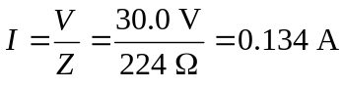
c)
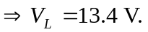
d) 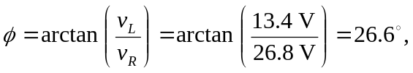 and the voltage leads the current.
e)

